Faunal Analysis Student Handout

Vocabulary

Abundance: count of individuals per species, compares how common one species is to another
Archeology: the scientific study of humans within the past
Biomass: the amount of meat that an animal can yield depending on the animal’s size
Classification: grouping objects into certain categories based on their attributes
Minimum number of individuals (MNI): estimates the lowest number of individual animals within a given species present on a site
Number of identified specimen (NISP): total count of bones per species
Qualitative: based on observable attributes (qualities) such as size and shape
Quantitative: based on measured amounts (quantities) such as counts
Taxon: category of organisms based on biological characteristics
Taxonomy: scientific classification of organisms into hierarchical categories
Ubiquity: records species presence or absence
Zooarcheology: the study of animal bones at archeological sites

Introduction

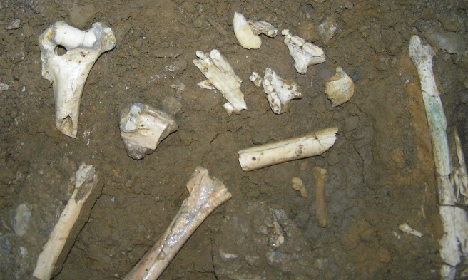
Bear bones at Oregon Caves National Monument. National Park Service.
Archeology is the scientific study of humans within the past. Archeologists use many scientific methods to understand ancient ways of life, ranging from biology to chemistry to geology.

Zooarcheologists study animal remains found on archeological sites, such as bones, teeth, and shells. They perform faunal analysis to answer many questions, including:
- What types of animals did people in the past eat?
- How did they obtain these animals?
- What did their surrounding environment look like?

Taxonomy

Taxonomy is the scientific classification of organisms into groups based on their biological characteristics. Taxa include: domain, kingdom, phylum, class, order, family, genus, and species. Archeologists use the qualitative properties of bones to classify them according to taxonomic group and skeletal part.
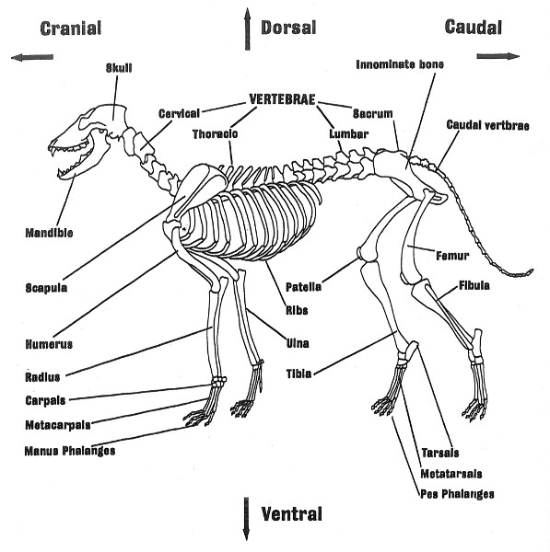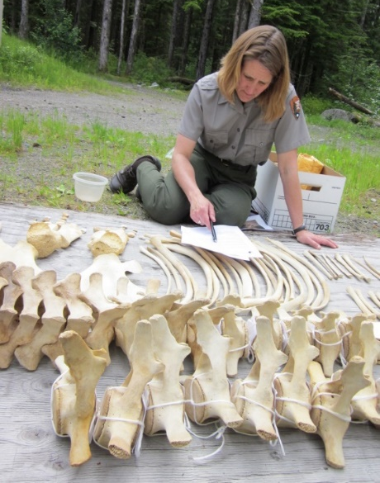
Left: Dog skeleton (Illinois State Museum). Right: Researcher cataloguing bones (National Park Service).

If the bones are well preserved, archeologists can identify them down to a specific species. However, bones are often weathered by wind and rain, gnawed by scavenger animals, trampled and shattered, or naturally decompose over time. All of these factors make it hard for archeologists to classify them. In those cases, archeologists record the smallest biological category that they can.

Quantification

Archeologists then use many different quantitative methods to interpret their classification results. Say an archeologist is studying an 18th-century house site and wishes to know if the occupants relied more on wild or domesticated animals. They find the following:
Species | Bone Count
Chicken | 15
Cow | 2
Turtle | 10
Turtle shells. National Park Service.

Ubiquity

Ubiquity records whether a given species is present or absent on a site. Ubiquity analysis allows archeologists to quickly know which species were found. This method also accounts for different bone preservation. In the example above, cow bones may have been lost over time due to erosion or decomposition yet are given just as much importance as chicken and turtle bones.

NISP

The number of identified specimens (NISP) is a count of how many bones of a given species were found. NISP allows archeologists to easily compare species abundance. However, NISP implies that each bone came from a different animal. This means that it often overestimates the number of animals on a site. In this example, NISP counts fifteen individual chickens. However, the bones may all from the same chicken—or even the same bone that shattered in the ground.

MNI

Archeologists also use the minimum number of individuals (MNI). This technique estimates how many animals of one species were on a site. In the example, if both cow bones were right femurs (upper leg bone) then there were at least two different cows. MNI only works if an archeologist is able to identify bones by specific species and skeletal part. Also, unlike the NISP method, it tends to underestimate how many animals were present. In the example, if all fifteen chicken bones were different parts of the skeleton MNI would still record only one chicken.

Biomass

Finally, archeologists note an animal’s biomass, or the total amount of meat each animal can provide depending its size. Biomass analysis often balances out NISP and MNI counts. For instance, one cow provides much more meat than a chicken or a turtle. Therefore, even though cows have the lowest NISP and MNI in this example, they likely made up a very large part of site occupants’ diets.
Each of these techniques has advantages and disadvantages. Archeologists often perform all four then compare and contrast their findings to interpret a site.

Case Study: Magnolia Plantation

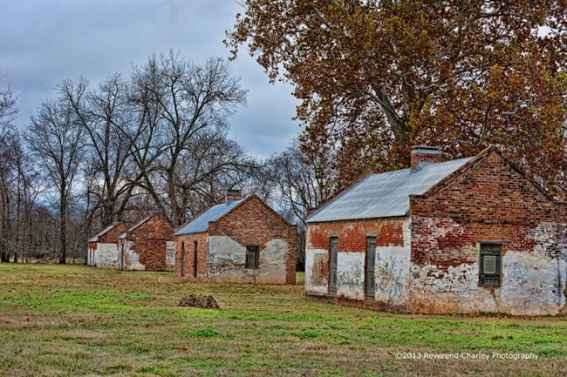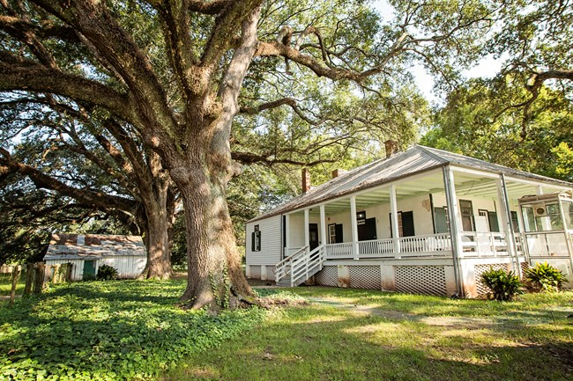
Left: Cabins for enslaved people and later tenants at Magnolia. Reverend Charlie photography; Right: Overseer house also used as a hospital for enslaved people. National Park Service.
Magnolia Plantation, established by the LeComte family in 1835, is one of many sites in Cane River Creole National Historical Park in Louisiana. During the 19th century, Magnolia was the largest cotton plantation in the area and had the highest number of enslaved workers.

Historical documents, such as account books, overseer records, diaries, and letters, give an image of enslaved people’s day-to-day lives on the plantation. From these documents, archeologists know that enslaved people helped raise cows and pigs for meat and dairy products, and used horses for plantation labor. They received rations of corn meal, pork, and molasses and occasionally beef, flour, rice, macaroni, and oysters from their owners. Enslaved people also had a vegetable garden near their cabins where they grew their own food.

While excavating at Magnolia, archeologists discovered many animal bones in and around the cabins. Their findings show that enslaved people were eating several other types of food not mentioned in the plantation records.
Taxon | Common Name | Count | Weight (gr) | % of Total Assemblage
Animalia | Unidentified | 29 | 11.57 | 2.63
Mammalia | Unidentified | 883 | 1664.32 | 79.98
Equidae | Horse | 3 | 6.87 | 0.27
Bovidae | Cow | 10 | 296.58 | 0.91
Suidae | Pig | 35 | 143.67 | 3.17
Cervidae | Deer | 6 | 10.11 | 0.54
Procyonidae | Raccoon | 1 | 1.45 | 0.09
Leporidae | Hare, Rabbit | 2 | 0.02 | 0.18
Aves | Bird | 17 | 11.04 | 1.54
Meleagrididae | Turkey | 1 | 0.75 | 0.09
Testudinidae | Tortoise | 33 | 23.13 | 2.99
Trionychidae | Soft shell turtle | 3 | 1.26 | 0.27
Emydidae | Box turtle | 1 | 4.07 | 0.09
Kinosternidae | Mud turtle | 2 | 1.90 | 0.18
Osteichthyces | Bony fish | 7 | 5.68 | 0.63
Sciaenidae | Drum | 2 | 1.15 | 0.18
Ictaluridae | Freshwater Catfish | 2 | 1.58 | 0.18
Lepisosteidae | Gar | 35 | 8.32 | 3.17
Bivalvia | Bivalve | 11 | 14.98 | 1.00
Gastropoda | Snail | 5 | 0.12 | 0.45
Subtotal | Total | 1088 | 2208.57 | 98.55
Magnolia Plantation faunal analysis. Adapted from Keel, Bennie C. A Comprehensive Subsurface Investigation at Magnolia Plantation. Southeast Archeological Center, National Park Service, 1999, 58.

The turtles, fish, and bivalves (mollusks) indicate that enslaved people went to the nearby Cane River and ponds to gather food. They may have caught rabbits and raccoons in small traps and hunted deer and turkeys.

Archeologists then compared their faunal analysis results with other evidence. Excavated artifacts like gunflints and bullets showed that enslaved people did indeed go hunting.

When interviewed by ethnologists, many people living at Magnolia in the 1900’s discussed fishing in the Cane River and gathering crawfish in the ponds. They also recalled the many pigs that roamed the plantation grounds. Together this information helped archeologists reveal the wide variety of food eaten by enslaved people at Magnolia and understand the various ways they obtained it.

